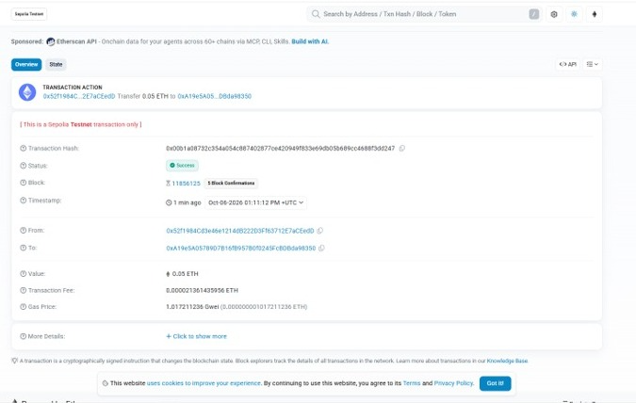
Sepolia Transaction Hash: 0x00b1a08732... | Etherscan Sepolia

Transaction hash:
0xd7eb7c834a24de17ffc0a1aea866e6c60eab0e96967f78ecb6f9c610c671349c

